Cloud computing & Azure Foundation: Module 1, Lesson 4  
How to start Azure Hands-On Lab

## Overview

In this lab, you will provision a Linux VM. You will run to attach both new and existing disks to Linux virtual machine through the Azure portal.

## Objectives

In this hands-on lab you will learn how to:

* How to create and manage Linux VM
* Log in to Azure portal with a Microsoft account
* View the Azure portal service associated with Virtual Machine

## Prerequisites

The following are required to complete this hands-on lab:

* A Microsoft Azure subscription ([Module 1 Lesson 1 Lab](https://github.com/MSFTImagine/computerscience/tree/master/Instructor-Led/Module1/Labs))
* A Microsoft account ([Module 1 Lesson 1 Lab](https://github.com/MSFTImagine/computerscience/tree/master/Instructor-Led/Module1/Labs))
* A web browser

Note: The Azure portal is continually improved and changed. The steps in this exercise reflect the user interface of the Microsoft Azure portal at the time of writing, but may not match the latest design of portal.

## Exercises

This hands-on lab includes the following exercises:

* Exercise 1: Create a Linux Virtual Machine.
* Exercise 2: View VM configuration and attach a data disk to Linux VM in the Azure portal.

## Exercise 1: Create a Linux Virtual Machine

1. Azure Portal Web Site : <https://portal.azure.com>. Sign into the portal. After signing in you will be take to the Microsoft Azure dashboard.

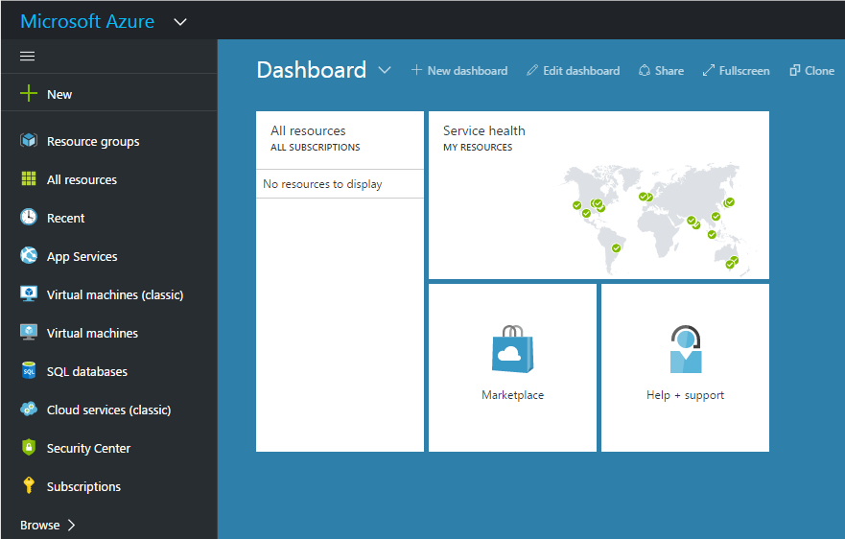

1. Signed into the Azure portal, click “+ New” in the upper left corner (Hub menu). On the Hub menu, click Virtual Machines > Ubuntu Server 14.04 LTS from the featured Apps.

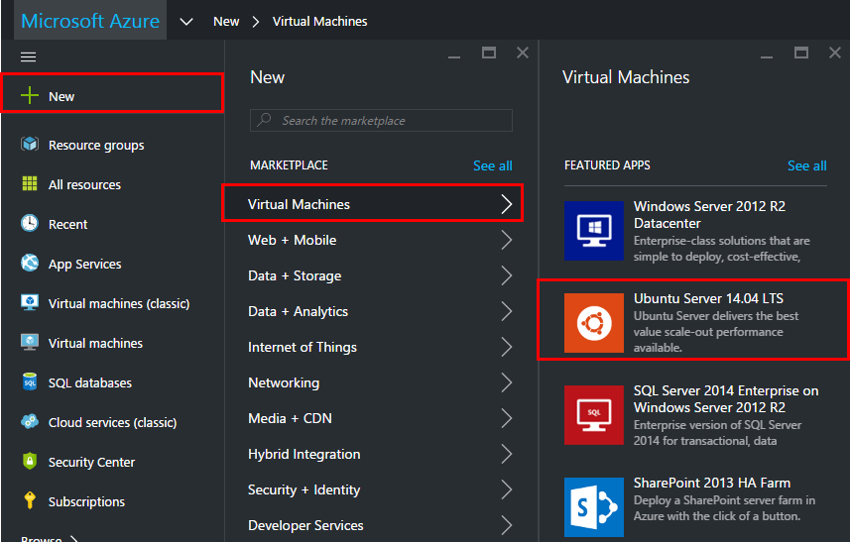

1. Verify at the bottom that the deployment model is resource manager and the Click “Create”.

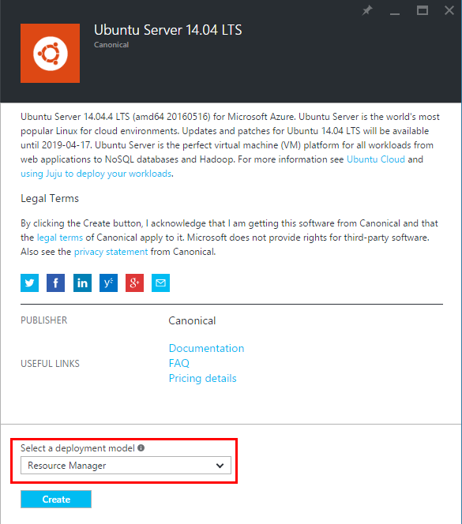

1. In basics (step 1), enter a Name for the virtual machine. The name cannot contain special characters.
2. Enter a User name, and a strong Password. The password must have at least 3 of the following: 1 lower case character, 1 upper case character, 1 number, and 1 special character. You'll need the user name and password to log on to the virtual machine.
3. If you have more than one subscription, specify the one for the new virtual machine, as well as a new or existing Resource group and an Azure datacenter location.

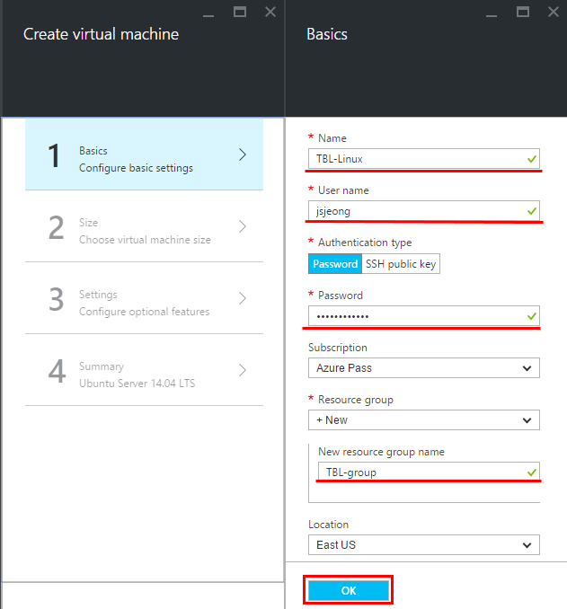

Resource groups are containers that help you manage a collection of Azure resources. A resource can only exist in a single resource group, and you can't nest resource groups; however, you can link resources from another resource group in a resource group. In this lab, you have to create new resource group name, because there is no existing Resource group at the time of creating the new VM. (ex. TBL-group)

Regarding location, you can choose from datacenters at different locations to run your service, thus optimizing network distance for your target audience. You have to think about network latencies that are imposed by geographical distances. Click the “OK” button.

1. In Size section (step 2), select an appropriate virtual machine size for your needs. Each size specifies the number of compute cores, memory, and other features, such as Premium Storage.

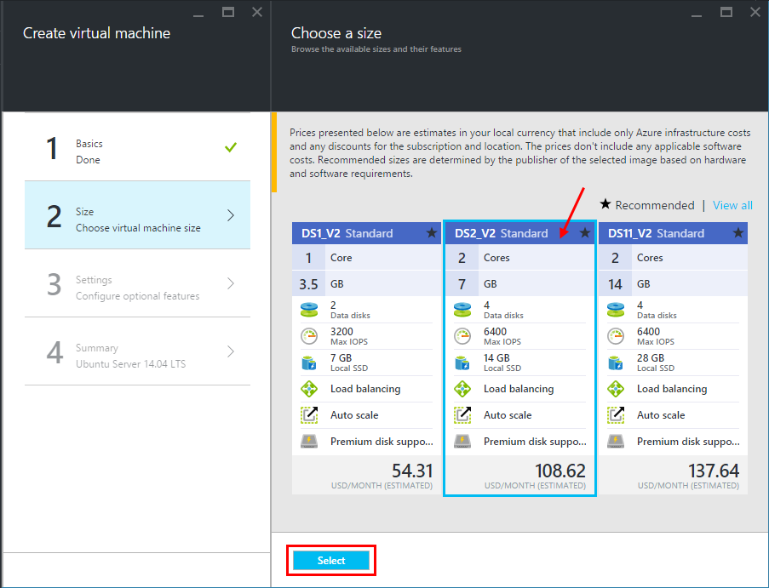

Azure offers a variety of VM sizes. Each size is identified by A-series, D-Series, and so on. When deploying VMs you get charged for them whether they’re in use or not. Your credits decrease according to the VM’s size. When you’re finished using a VM, you must suspend or delete each VM to avoid unnecessary charges. Once suspended, a VM is easily restarted so you can pick up where you left off and continue using it. Choose the DS2_V2 size for Ubuntu.

1. Click Settings (step 3) to see storage and networking settings for the new virtual machine.

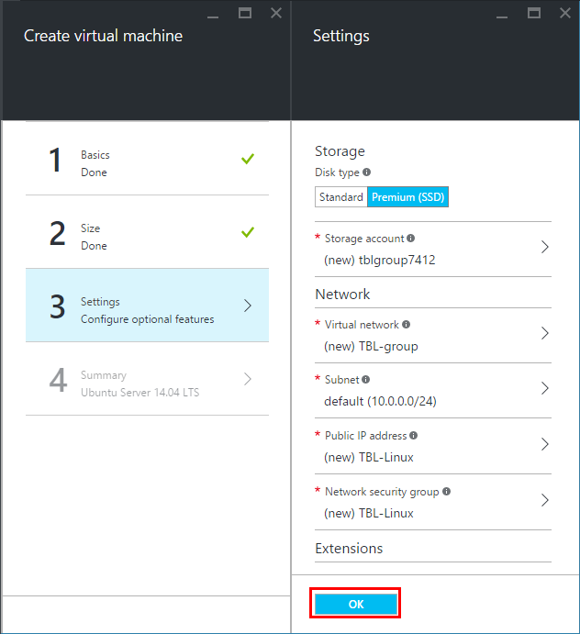

In step 3, virtual networks are logically isolated from each other in Azure. You can configure their IP address ranges, subnets, route tables, gateways, and security settings, much like a traditional network in your data center. In this lab, you don’t configure the value instead of default value; the VMs can’t access each other.

1. Click **Summary** (step 4) to review your configuration choices. When you're done reviewing the settings, click **Create**.

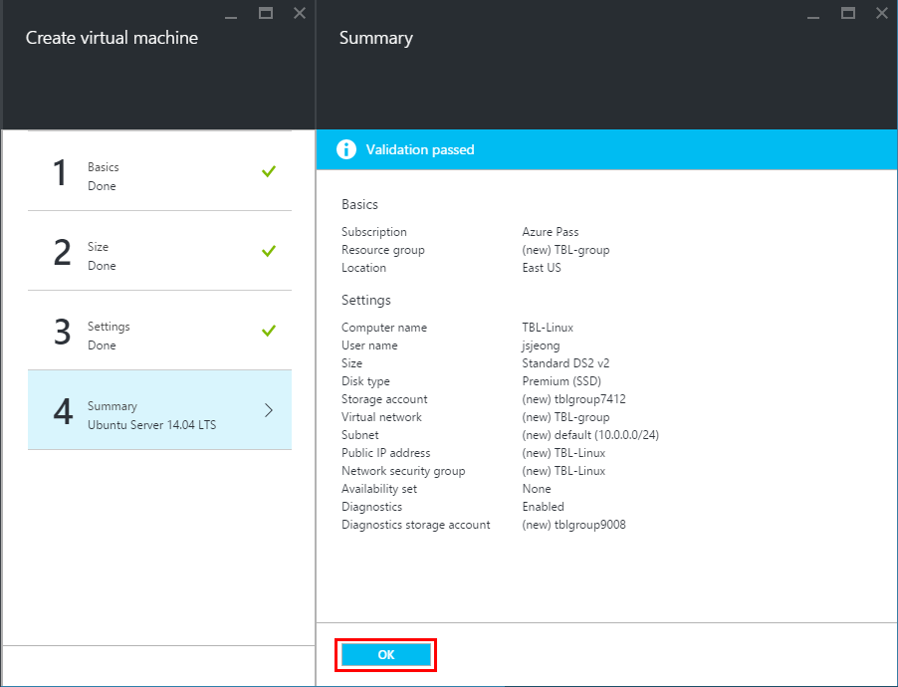

After you have clicked OK, wait for the virtual machine to be provisioned and the status to show as running. (This can take a while) While it is provisioning, the user will see the following message in dashboard.

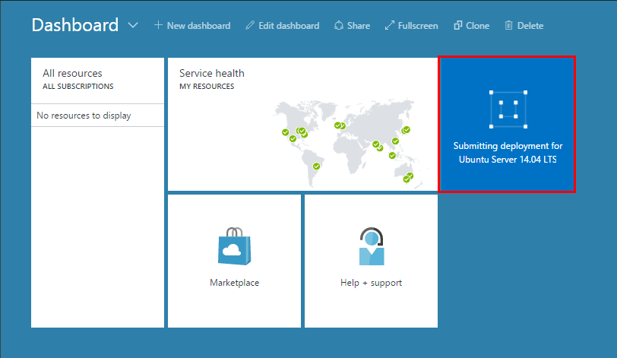

Exercise 2: View VM configuration and attach a data disk to Linux VM in the Azure portal.

1. In the Azure portal, view the summary information for your Linux VM. Check your IP of Linux VM and note this information for connecting VM using terminal program in next lab.

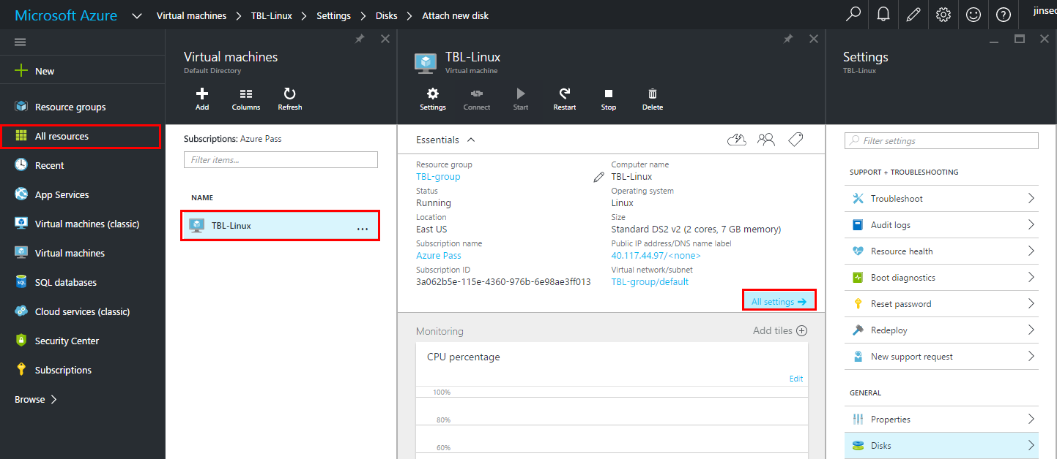

1. Attach a data disk to Linux VM.
2. On the Hub menu, click “Virtual Machines”. And, select your virtual machine (ex. TBL-Linux) from the list. To the right, click “Disks” in general.

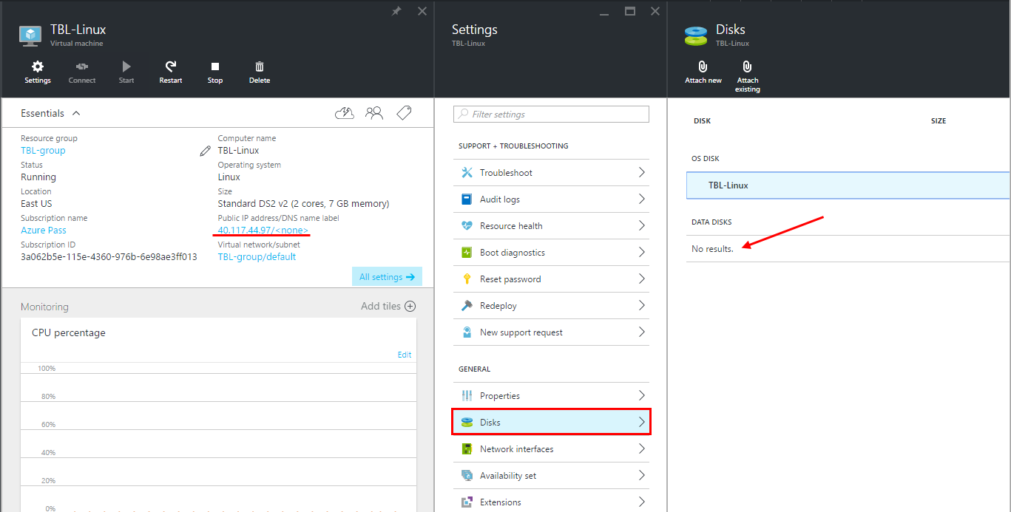

1. On the Disks section, click “Attach new”. Review the default settings, update as necessary, then click “OK”.

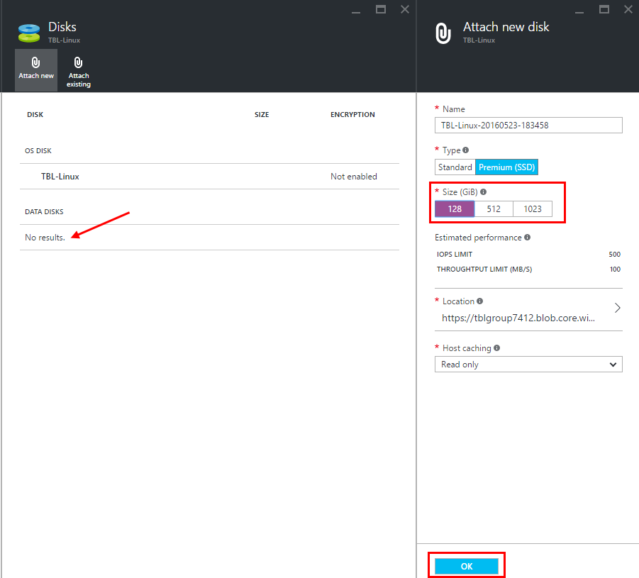

1. After 5-10 secs, you can see a new data disk in Disks section.

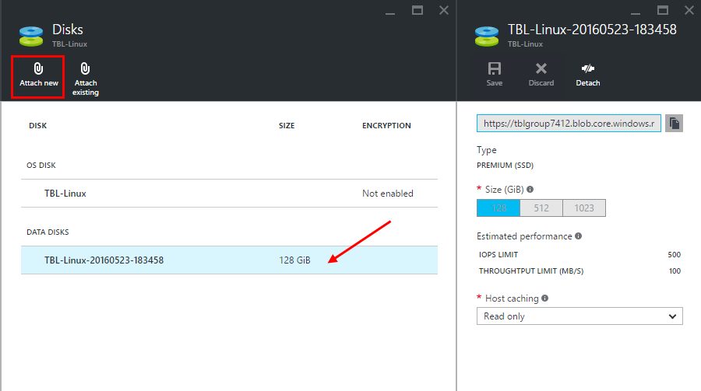

## Summary

In this hands-on lab, you learned how to:

* How to create and manage Linux VM
* How to attach a data disk to Linux in portal.